20XX-01-XXXX

Road Curvature Decomposition for Autonomous Guidance

Author, co-author

Affiliation

**Abstract**

Vehicle autonomy is critically dependent on an accurate identification and mathematical representation of road and lane geometries. Many road lane identification systems are ad hoc (e.g., machine vision and lane keeping systems) or rely on polynomial approximations of road data and GPS positioning. A novel system is proposed in which geodetic road data is parsed along road directions and digitally stored in a road data matrix. Using mapping algorithms, the road data is converted to a smooth, differentiable path which connects critical road coordinates with curvature vectors and changes to road tangent angles. Different road data sources such as GPS or geographical scans were evaluated with this method and compared to current road design standards as per the American Association of State Highway and Transportation Officials (AASHTO). This approach takes advantage of standard roadway design practices, which rely on speed limit, superelevation, and empirical data for maximum lateral acceleration tolerance to determine acceptable radii of curvature for different classes of roadways. Successful implementation of this technology could accelerate autonomous vehicle’s navigation research and development for new guidance paradigms in addition to traditional machine vision-based systems.

Keywords: Trajectory Generation, Path Generation, Curvature, AASHTO, V2I, Vehicle-to-Infrastructure

**Introduction**

Road geometries play a circumstantial role in designing for transportation. In autonomous vehicles, the current level of vehicle autonomy depends heavily on light sensors or radar sensor for detecting both objects and lane markings on the road. Based on this sensor information, vehicles are able to generate paths and trajectory approximations of where the vehicle should be going. In motion planning, a path is defined a set of possible ways a vehicle can go from Point A to Point B. While trajectory is defined as the profile needed to go through that path given different constraints. For example, many trajectories can lie inside of a given path as shown in Figure 1. Given constraints can be in the form of differential constraints from equations of motion, geometrical constraints or dynamic constraints from vehicle limits.

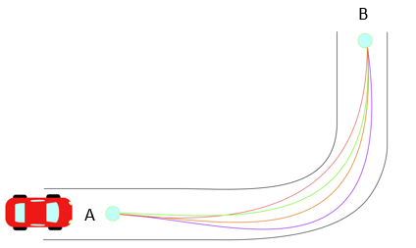

From literature, local trajectory generation techniques utilize different mathematical models. Such methods can be classified as roadmap-based planning [], sampling-based planning [], probabilistic methods [], and variational methods []. Most of these methods rely with the aid of vehicle sensors to generate their navigation map, for example discretizing areas of space from an image and classifying them as either navigation feasible or not. However, variational methods can be exploited outside of its dependence on image processing.

Variational methods arise from optimizing functionals with non-holonomic constraints (i.e. constraints on the velocity and acceleration). The methods yield polynomial solutions of high order that are treated as boundary value problems (BVP) during vehicle navigation. Along with variational methods, Clothoid functions (Cornu Spirals or Euler Spiral) are often studied in autonomous research because of their effectiveness to connect a straight line with a constant radius curve. Such that clothoids are used for road design and local trajectory generations. [][][]

These trajectory methods are then combined with optimization theory to be implemented into controllers for navigation purposes. In general, these trajectories focus on providing a continuous function (up to the third derivative) while being smooth (i.e. minimizing the jerk $\frac{d^{3}x}{dt^{3}}$). However, trajectories can also be generated from offline information that comes from different media such as GPS or geospatial data. Therefore, offline data provides a static calculation of the trajectories a vehicle should have regardless of any sensor error that vehicles could encounter during their trajectory calculations.

Thus, the objective of this research study is to develop a deterministic technique for identifying the centerline path of travel lanes using smooth, differentiable, parametric equations and geospatial road data. The rest of this paper is composed of the following sections: Method Formulation, Implementations, Recommendations and Conclusions.

**Method Formulation**

**1.1 Method Idea**

The method presented formulates a point particle dynamics approach describing the vehicle’s motion as it passes through a road. A Frenet-Serret reference frame is used along with unit vectors of N (normal), T (tangential), and B (binormal, out of plane) as shown in Figure. For this paper, it is assumed that the vehicle navigates on a 2D Euclidean Space.

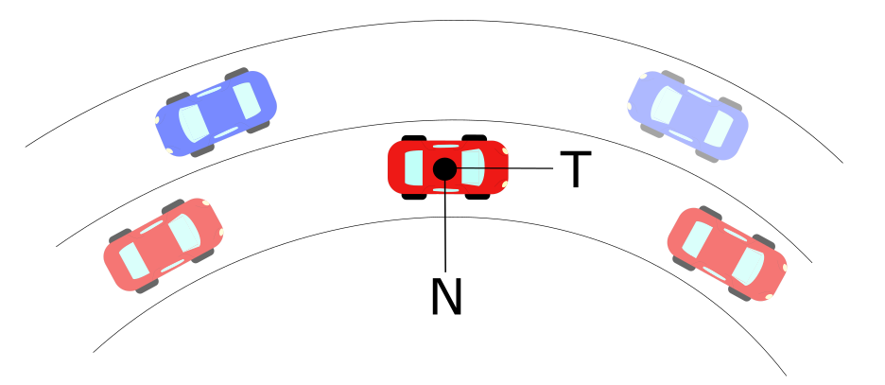

*Figure 2 - Normal-Tangential Coordinates Example in Vehicle’s Center of Mass*

As the vehicle goes through the curve, it is limited to constraints provided by road geometry and friction limits on the vehicle tires [12] [13]. These limits are related to the acceleration a vehicle goes under circular motion, which is denoted as:

$$a=\dot{v} T+{κv}^{2} N$$

Where:

a = Total Acceleration of Vehicle (m/s2)

v = Tangential Velocity of Vehicle (m/s)

$κ$ = Curvature at an Instantaneous Point (m-1)

N =Normal Unit Vector

T= Tangential Unit Vector

Curvature can be defined analytically, physically and geometrically. It measures how fast the tangential unit vector T changes with respect to an instantaneous point in the curve. Many researchers have been developed on basis of curvature formulation [][][]. By Frenet-Serret definition of coordinates, curvature can be expressed in a vector form that has a direction parallel to the Normal Unit Vector shown in Figure 2 . Similarly, a vector perpendicular to the curvature direction will provide a velocity tangent vector approximation at that point. This velocity vector provides a heading angle to the desired trajectory that is needed to follow a road path. Thus, it is possible to obtain a heading angle representation of any trajectory as long as curvature can be obtained from a discrete data set.

**1.2 Discrete Curvature Formulation**

To obtain the curvature, let a scalene triangle with corners A, B, C have a circumscribed circle of radius R in Euclidean 2D space as shown in Figure.

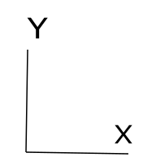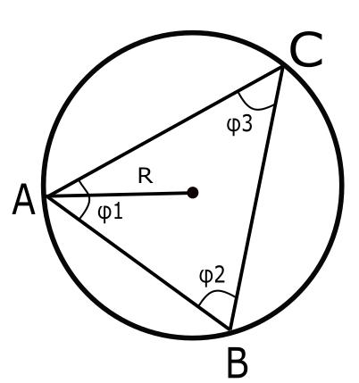

Circumscribed Circle in Scalene Triangle

If we let a vector D be the cross product in between the vectors AB and AC, the direction will be pointing out normal to the plane defined by the intersection of AB and AC. By definition of the magnitude for cross product:

$$\left\|D\right\|= \left\|AB ×AC\right\|= \left\|AB\right\| \left\|AC\right\| \sin{ϕ_{1}}$$

Let a vector E be the cross product of D with the vector AB, defining this new vector in the direction of $e_{1}$ as shown in Figure. Let the magnitude of vector E be defined as:

$$\left\|E\right\|=\left\|D×AB\right\|={\left\|AB\right\|}^{2}\left\|AC\right\| \sin{ϕ_{1}}$$

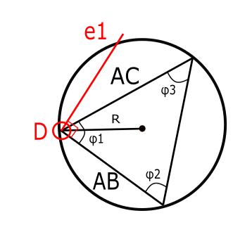

Similarly, let a vector F be the cross product of D with the vector AC, defining this new vector in the direction of $e_{2}$. Let the magnitude of vector E be defined as:

$$\left\|F\right\|=\left\|D×AC\right\|=\left\|AB\right\|{\left\|AC\right\|}^{2} \sin{ϕ_{1}}$$

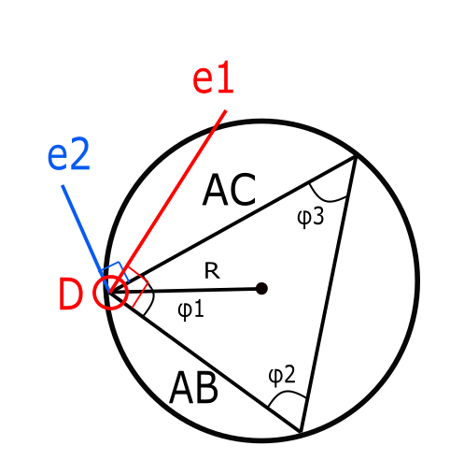

The unit vectors of $e_{1}$ and $e_{2}$ are defined by the following:

$$e_{1}=\frac{E}{{\left\|AB\right\|}^{2}\left\|AC\right\|\sin{ϕ_{1}}}$$

$$e_{2}=\frac{F}{\left\|AB\right\|{\left\|AC\right\|}^{2}\sin{ϕ_{1}}}$$

By definition, the midsection of any triangle’s side intersects with each other at a point P as shown in Figure. These intersecting lines denote two triangles with the same angle $ϕ_{1}$ in between the unit vectors and their corresponding midsections as shown below.

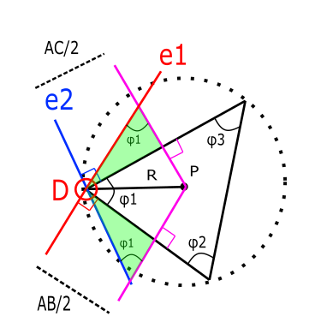

From these triangles, it is possible to break the vector DP into components along unit vectors $e_{1}$ and $e_{2}$ to obtain a new definition of DP in a different set of coordinates as follows:

$$DP_{1}=\frac{AC}{2\sin{ϕ_{1}}} e_{1}=\frac{E}{2{\left\|AB\right\|}^{2}\sin^{2}{ϕ_{1}}}$$

$$DP_{2}=\frac{-AB}{2\sin{ϕ_{1}}} e_{2}=\frac{-F}{2{\left\|AC\right\|}^{2}\sin^{2}{ϕ_{1}}}$$

From our previous definition of the vector D, it is possible to simplify further:

$$DP_{1}=\frac{{\left\|AC\right\|}^{2}E}{2{\left\|D\right\|}^{2}}$$

$$DP_{2}=\frac{{-\left\|AB\right\|}^{2}F}{2{\left\|D\right\|}^{2}}$$

With these components, it is possible to obtain the magnitude as follows:

$$DP= \frac{{\left\|AC\right\|}^{2}E}{2{\left\|D\right\|}^{2}}- \frac{{\left\|AB\right\|}^{2}F}{2{\left\|D\right\|}^{2}}$$

$$R= \frac{{\left\|AC\right\|}^{2}E-{\left\|AB\right\|}^{2}F}{2{\left\|D\right\|}^{2}}$$

Using previous definitions of E and F:

$$R= \frac{{\left\|AC\right\|}^{2}\left\|D×AB\right\|-{\left\|AB\right\|}^{2}\left\|D×AC\right\|}{2{\left\|D\right\|}^{2}}$$

Using previous definition of D, it is possible to obtain the radius of the prescribed circle in terms of only the difference in between points A, B and C.

$$R= \frac{{\left\|AC\right\|}^{2}\left\|(AB×AC)×AB\right\|-{\left\|AB\right\|}^{2}\left\|(AB×AC)×AC\right\|}{2{\left\|(AB×AC)\right\|}^{2}}$$

Using the previous definition, it is possible to apply the formulation of R to differentially small arc segments as it is shown below.

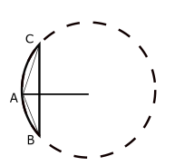

Scalene Triangle in Arc-Segment

The radius of this circumscribed circle is called radius of curvature, and its inverse is known as curvature denoted as:

$$κ=\frac{1}{R}$$

Through this definition, it is possible to extend the application of this discrete radius of curvature and applying it to long-discrete arc segments as shown in Figure:

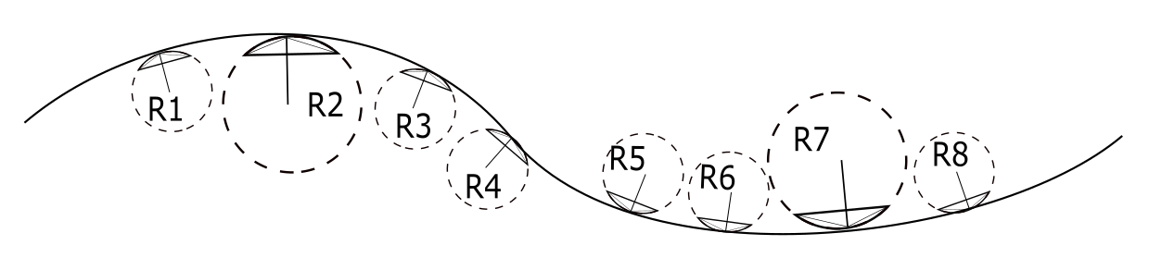

Road Section with Discrete Sections

**1.3 Heading Angle Calculations**

By sampling at a rate of three location points per curvature point, it is possible to create a discrete representation of the road with curvature data. To obtain the heading angle, two options were used. The first one used comes from the well-established definition of heading angle from trigonometric relationships explained in the Appendix:

$$θ\left(s\right)= \int{κ\left(s\right)ds}$$

The second one involves an orthogonal phase shift to the curvature direction. Which by definition of the Frenet-Serret, can be obtained from the components of the curvature previously calculated in Equation (#). Using the discrete curvature formulation, the two heading angle calculations were implemented in the next section.

**Implementations**

Typical highway roads are designed based on AASHTO guidelines to provide a natural, easy-to-follow path for drivers, such that the lateral force increases and decreases gradually as the vehicle enters and leaves a circular curve [16]. This leads to an approach of curvature generation based on AASHTO road geometry to obtain heading angles. To develop this, a geometric definition of radius of curvature is used to obtain both its magnitude and direction as shown in the Appendix [17]. The radius of curvature is computed from discrete points that represent coordinates of a road. To obtain different approximations, different methods to coordinates were used. The first method involved a base model of the road based on AASHTO guidelines, and the second method involved using Google Earth coordinates.

**AASHTO Base Model**

This model consisted on strictly using AASHTO guidelines to design an ideal highway road for a vehicle traversing at constant 60 mph. The curve consisted of 5 different sections that can be classified as: straight section, entrance transition, constant radius curve, exit transition and straight section. Applying the discrete geometric approach to this curve [A.2], curvature vectors were plotted with respect to the road segments as shown in Figure 3. The curvature magnitude was plotted with respect to road segments to obtain a base curvature profile as shown in Figure 4.



*Figure 3 - AASHTO Base Model: Road with Curvature Vectors*



*Figure 4 - AASHTO Base Model: Curvature κ vs. Cumulative Curve Length*

With the curvature profile established, two different approaches were used to confirm the heading angle approximation. One method involved obtaining the heading angle from trigonometric functions on the curvature vectors and add an orthogonal phase shift. The second method involved numerical integration of the curvature data to obtain a heading angle. The proof of the method is shown in [Appendix] and both methods are shown in Figure 5 and Figure 6. Results on heading angles with respect to road segments are shown in Figure 7.These resulting angles were used as input data on a controller developed in [Michael].



*Figure 5 - AASHTO Base Model: Orthogonal Phase Shift Approach*



*Figure 6 - AASHTO Base Model: Numerical Integration Approach*



*Figure 7 - AASHTO Base Model: Road with Velocity Vectors*

**Google Earth Model**

This model is based off a selection of points in Google Earth that represent a highway road with design speed of 60 mph. The points were picked as close as possible to resemble the road centerline of the highway. The road profile and resulting vectors from applying the aforementioned discrete geometry approach are shown in Figure 8. It is noticeable how the vector directions choose arbitrary tangent directions when the curve approaches a straight line section. The curvature magnitude with respect to length was also plotted in Figure 9 and it was observed that magnitude deviations increased considerably compared to the ideal AASHTO model.



*Figure 8 - Google Earth Model: Road with Velocity Vectors*



*Figure 9 - Google Earth Model: Curvature κ vs. Cumulative Curve Length*

The method was not efficient in calculating curvature magnitudes, but the direction of the heading angle obtained from the orthogonal phase shift still provided comparable results to those found by calculating with AASHTO as shown in Figure 10. Similarly, the resulting velocity vectors to guide the vehicle provide a suitable heading direction as shown in Figure 11. These resulting angles were used as input data on a controller developed in [Michael] to study the efficiency of navigating with this input information.



*Figure 10 - Google Earth Model: Orthogonal Phase Shift Approach*



*Figure 11 - Google Earth Model: Road with Velocity Vectors*

**Recommendations**

**Conclusions**

**Appendix**

A.1 – *Heading Angle Integration Formulation*

**Appendix**

A.1 - *Heading Angle Trigonometric Formulation*

The arc-length s of a curve is defined as the length traveled by a certain amount of degrees $θ$ along a constant radius r. If s is sufficiently small, a triangle can be formed in between these three parameters, which are related through geometry:

$$\sin{θ}=\frac{s}{r}$$

Defining r as the radius of curvature at the specific arc-length and letting $r=ρ$.

$$\sin{θ}=\frac{s}{ρ}$$

By the previous assumption of small angles: $\sin{θ}=θ$

Which leads to

$θ=\frac{s}{ρ}$ (1)

Let the Curvature $κ$ be denoted as $ρ=1/κ$

Substituting this definition into equation (1)

$$θ=κs$$

Assuming a differential section for $θ$ and $s$. Rearranging for $κ$:

$$κ=\frac{dθ}{ds}$$

By separation of variables and integration

$$\int{κds}= \int{dθ}$$

Which concludes that the angle of orientation as a function of arc-length s can be found through numerical integration of the curvature as:

$$θ\left(s\right)= \int{κ\left(s\right)ds}$$

**References**

1. M. Werling, J. Ziegler, K. Soren, and S. Thrun. *Optimal Trajectory Generation for Dynamic Street Scenarios in a Frenet Frame*, 2010
2. A. Kelly, B. Nagy, *Reactive Nonholonomic Trajectory Generation via Parametric Optimal Control*, 2003
3. Y. Sun, Z. Zhan, Y. Fang, L. Zheng, L. Wang, G. Guo, *A Dynamic Local Trajectory Planning and Tracking Method for UGV Based on Optimal Algorithm,* 2019
4. A. Takahashi, T. Hongo, Y. Ninomiya, G. Sugimoto, *Local Path Planning and Motion Control for AGV in Positioning*, 1989
5. A. Piazzi, C. Guarino lo Bianco, *Quintic G2-Splines for Trajectory Planning of Autonomous Vehicles,* 2000
6. D. Wilde, *Computing Clothoid-Arc Segments for Trajectory Generation*, 2009
7. H. Delingette, M. Hebert, K. Ikeuchi, *Trajectory Generation with Curvature Constraint based on Energy Minimization*, 1991
8. L. J. van Vliet, P. W. Verbeek, *Curvature and Bending Energy in Digitized 2D and 3D Images*, 1993
9. P. Guillaume, J. Schoukens, R. Pintelon*, Sensitivity of Roots to Errors in the Coefficient of Polynomials Obtained by Frequency –Domain Estimation Methods*, 1989
10. K. E. Atkinson, *An Introduction to Numerical Analysis*, 1989
11. O. M. O’Reilly, *Engineering Dynamics A Primer*, 2010
12. A.N. Pressley, *Elementary Differential Geometry*, 2010
13. H. B. Pacejka, *Tyre and Vehicle Dynamics*, 2006
14. T. D. Gillespie, *Fundamentals of Vehicle Dynamics*, 1992
15. M. P. do Carmo, *Differential Geometry of Curves and Surfaces*, 1976
16. AASHTO, *A Policy on Geometric Design of Highways and Streets*, 2011
17. A. Mjaavatten, *Curvature of a Discrete Curve in 3D Space*, 2018
18. M. Duhn, G. Parikh, J. Hourdos, *I-94 Connected Vehicles Testbed Operations and Maintenance*, 2019
19. Druta, A. S. Alden, *Implementation and Evaluation of a Buried Cable Animal Detection System and Deer Warning Sign*, 2019
20. SAE International, *J3016-Taxonomy and Definitions for Terms Related to Driving Automation Systems for On-Road Motor Vehicles,* 2018
21. William J. Hughes Technical Center, *Global Positioning System (GPS) Standard Positioning Service (SPS) Performance Analysis Report*, 2017
22. S. Heinrich, *Planning Universal On-Road Driving Strategies for Automated Vehicles,* 2018